**Doc External**

Anggota Kelompok

2201810943 - Muhamad Daffa Mennawi

2201760945 - Kevin Orlando Sutanto

2201752994 - Louis Choules

Step to Run Project

1. Open XAMPP
2. Start Apache and MySQL
3. Open [localhost / 127.0.0.1 | phpMyAdmin 5.0.3](http://localhost/phpmyadmin/)
4. Add “read_up” database
5. Open Laravel Project
6. Run “composer install” in cmd
7. Run “npm install” in cmd
8. Run “php artisan migrate:fresh –seed” in cmd
9. Run “php artisan serve” in cmd

**Code Program**

Route

We make some Routing for our website such as below.

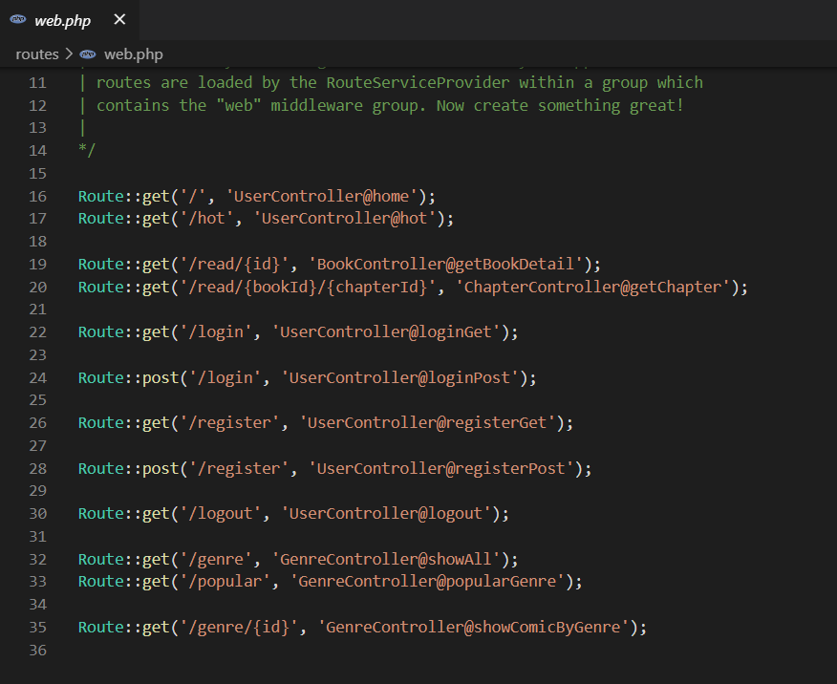

Env

Here is the env for our website.

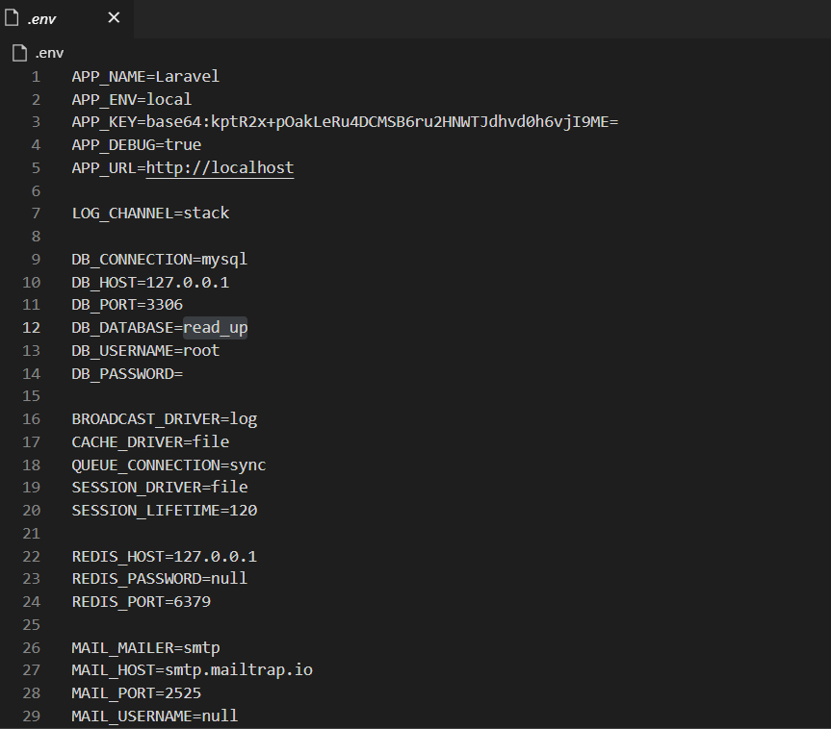

Database

Here we display a bit of our database table creation.

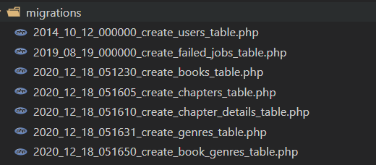

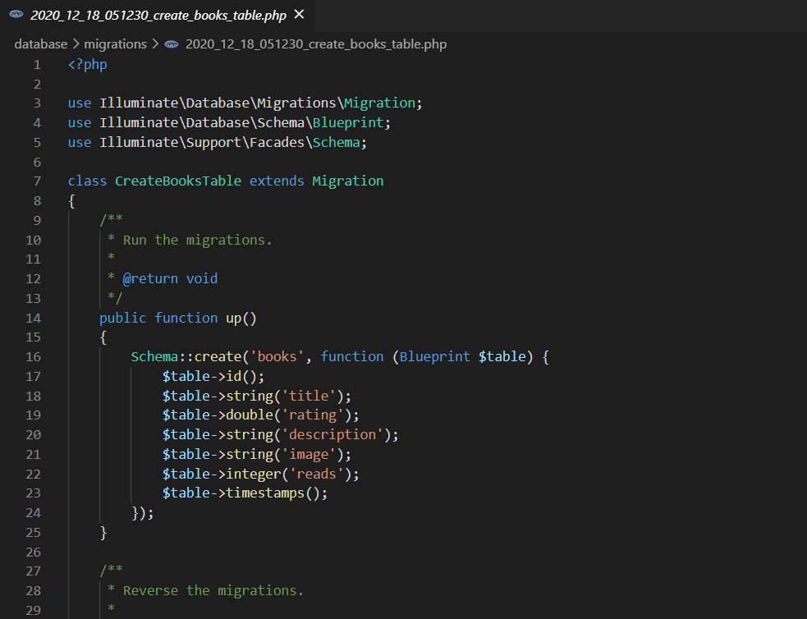

Model

We are create some models for our database such as below.

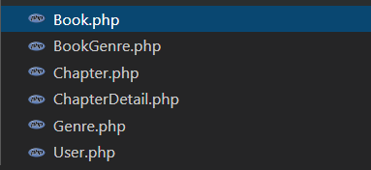

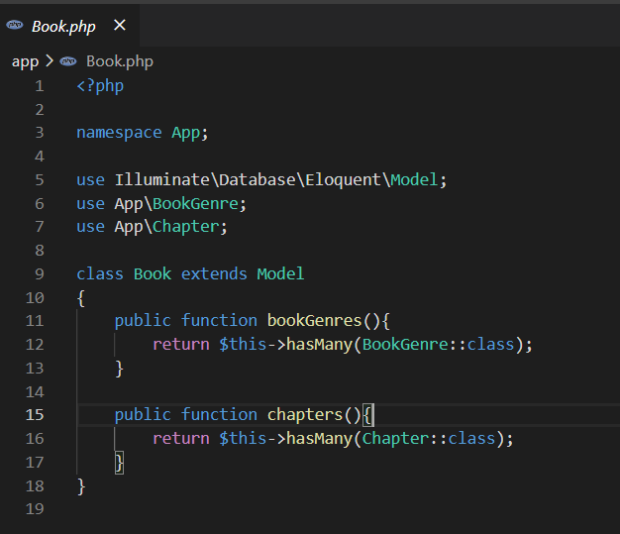

Seeding

For Seeding we are using Faker to make dummy data for our website. We also using Factory for making dummy User data (all data is random except for the password, the password for each dummy user is “password”).



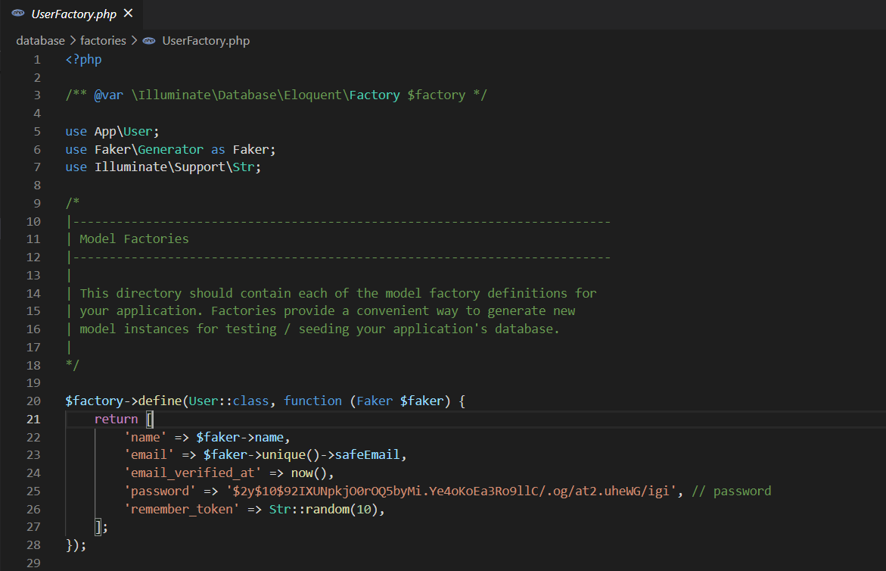

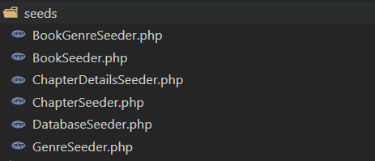

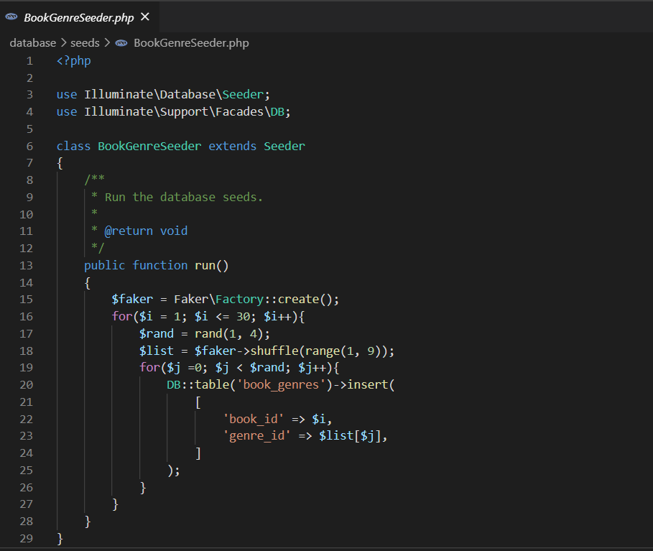

Controllers

We have some controller to help us connect from database to our website. We are using Eloquent and also query builder to fetch data from database.

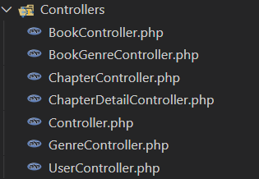

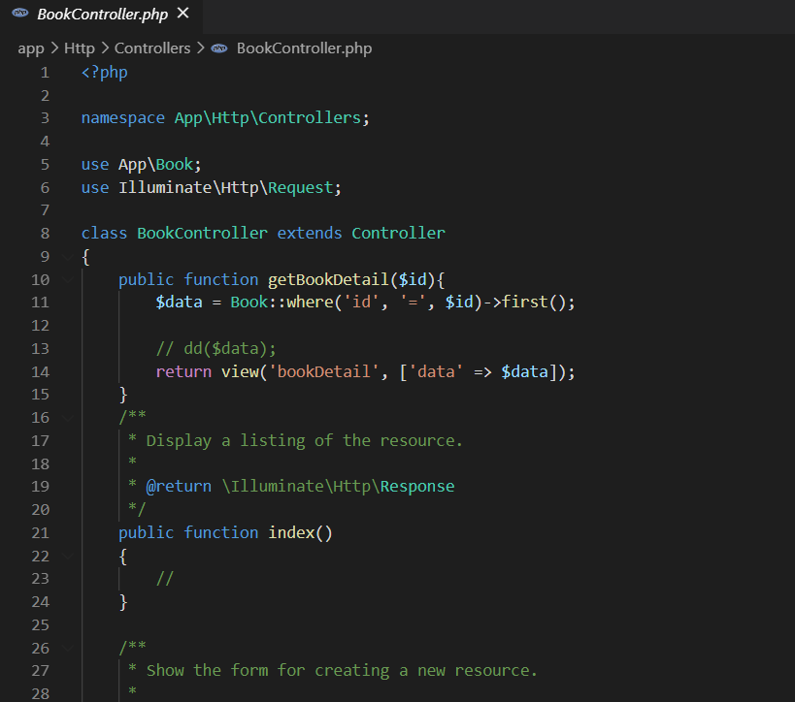

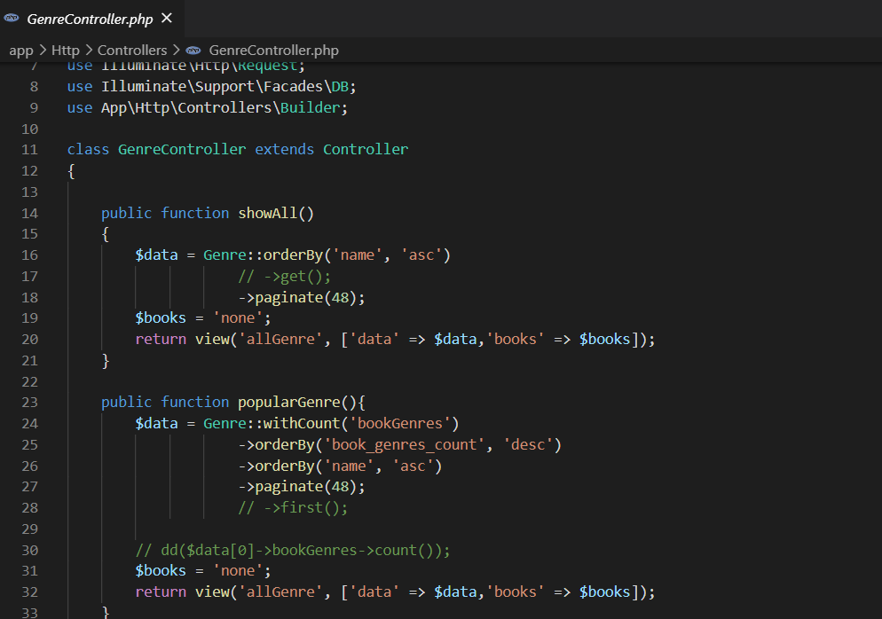

Layout

We are divide our website to some part of such as component (footer and navbar) and layout (Home, Login, Register, ect).

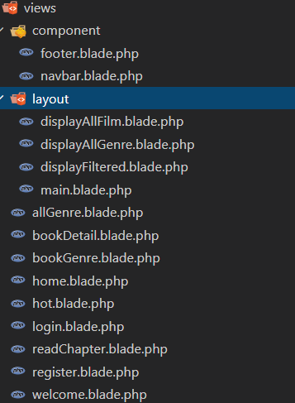

* Navbar (Component)

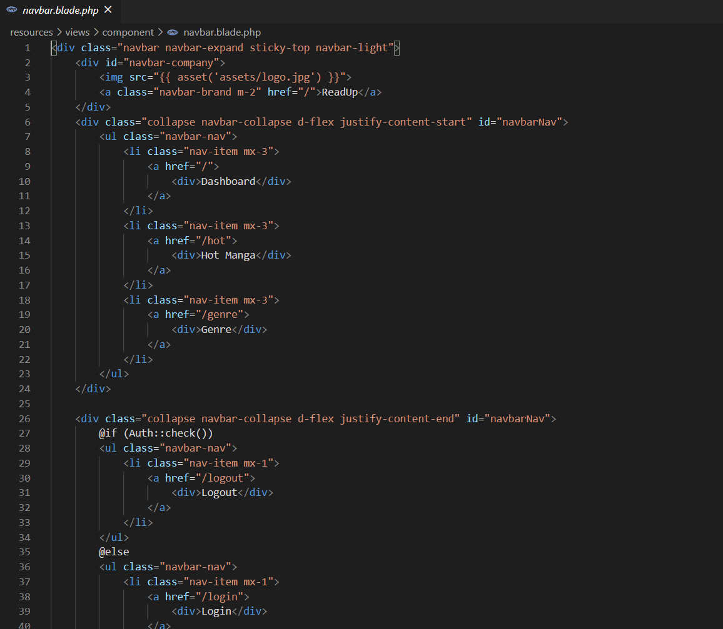

* Main Layout (Layout)

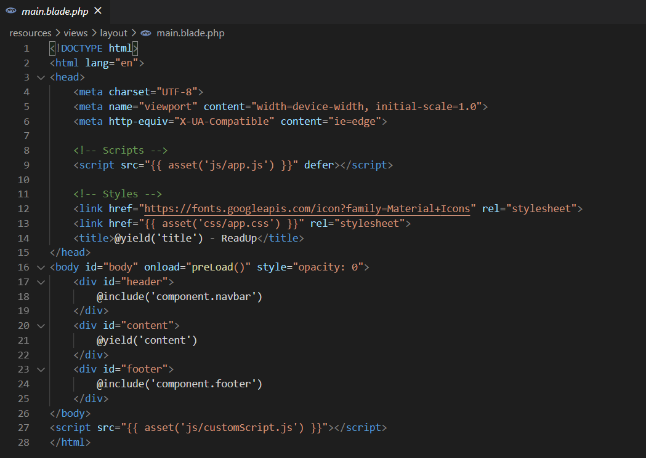

* Book Genre Page (Page)

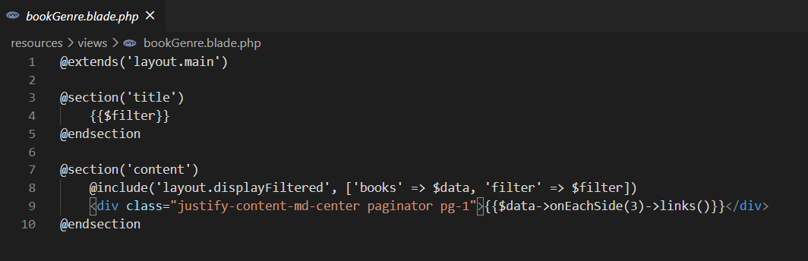

Request

We have some validation in our Request using Custom Http Request.

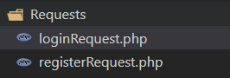

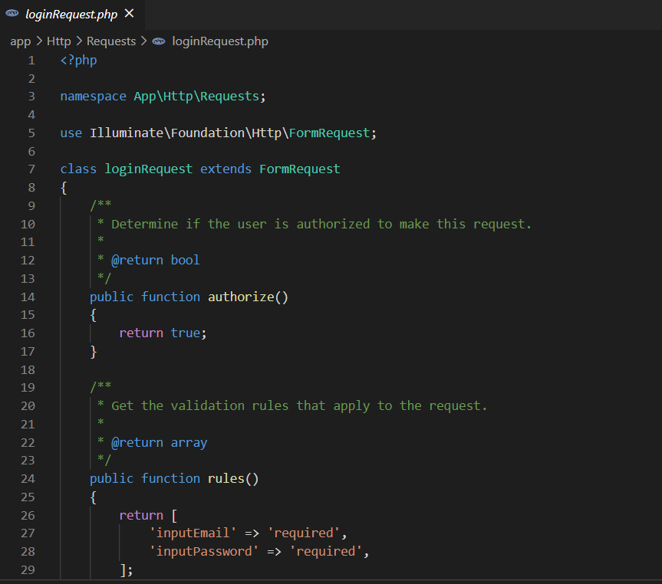

Assets

For assets and styling we are using Bootstrap and also Laravel UI.

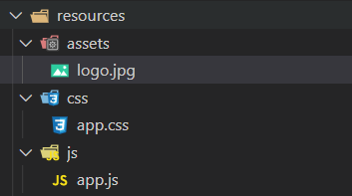

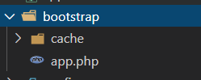

**Result**

Home Page  


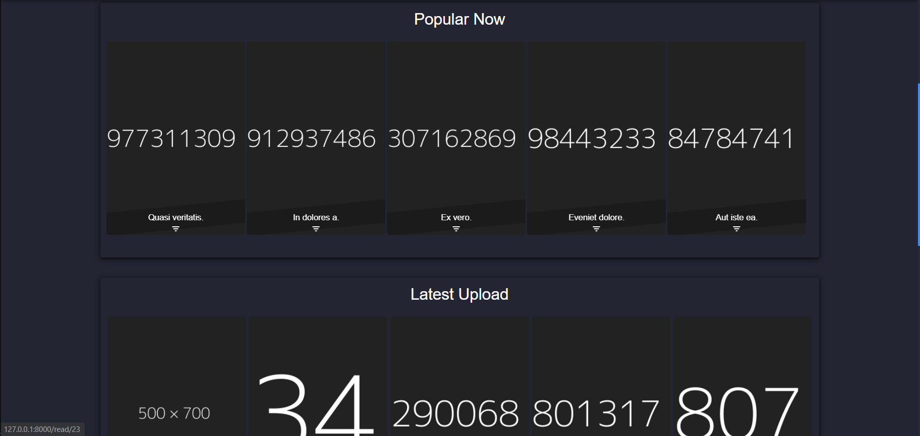

Hot Manga

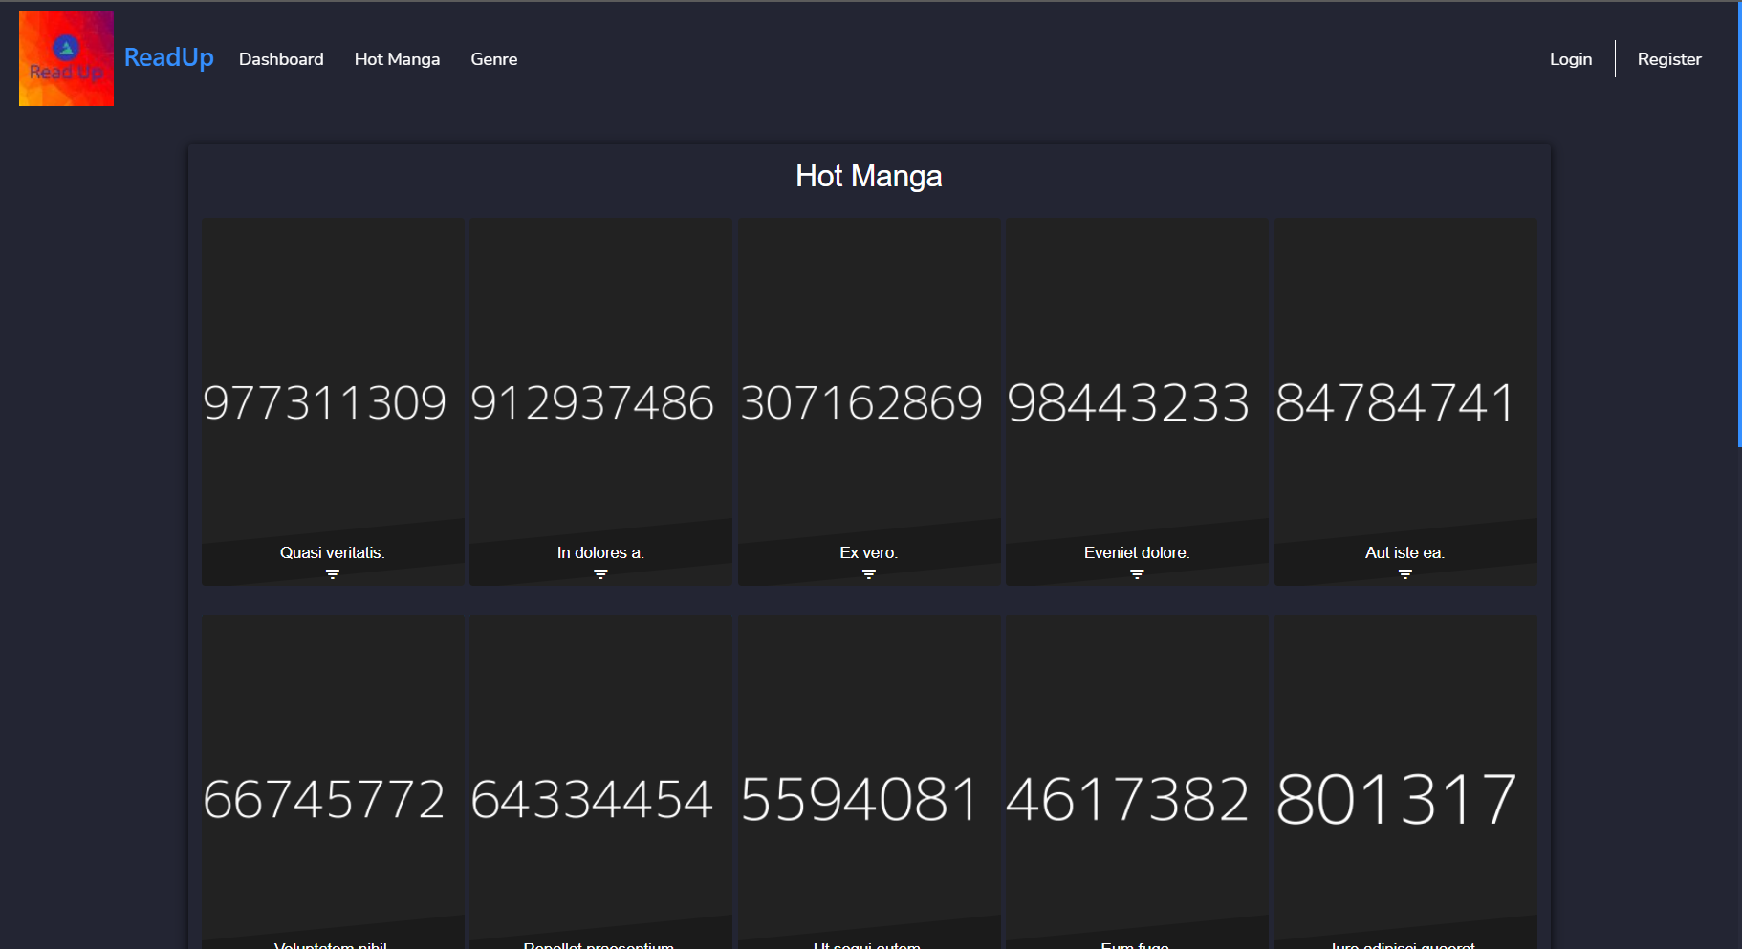

Display Genre By Alphabet

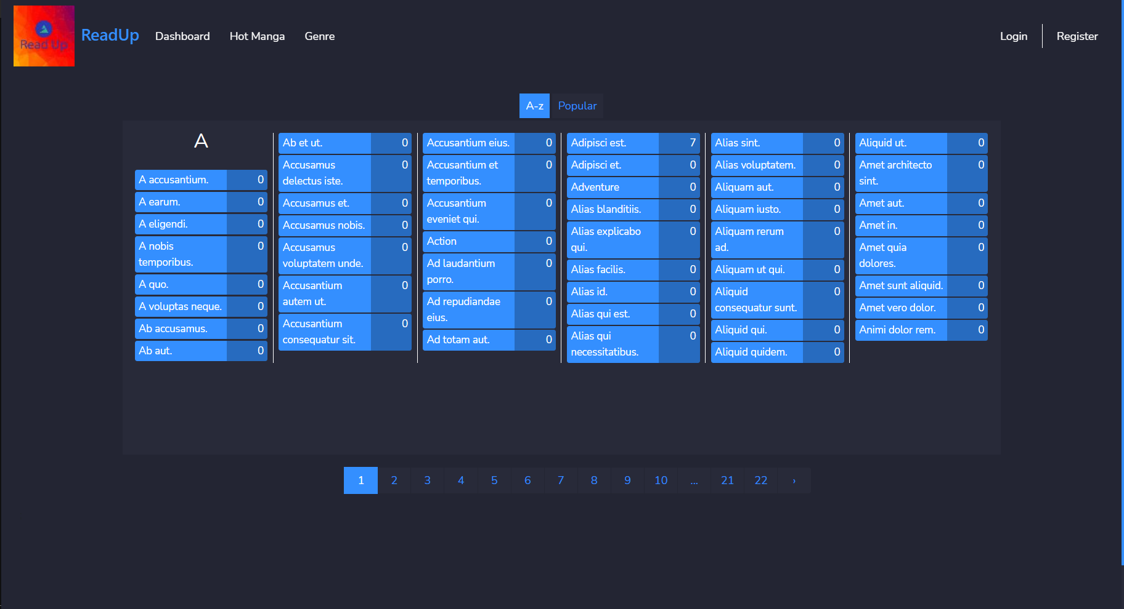

Display Genre by Popularity

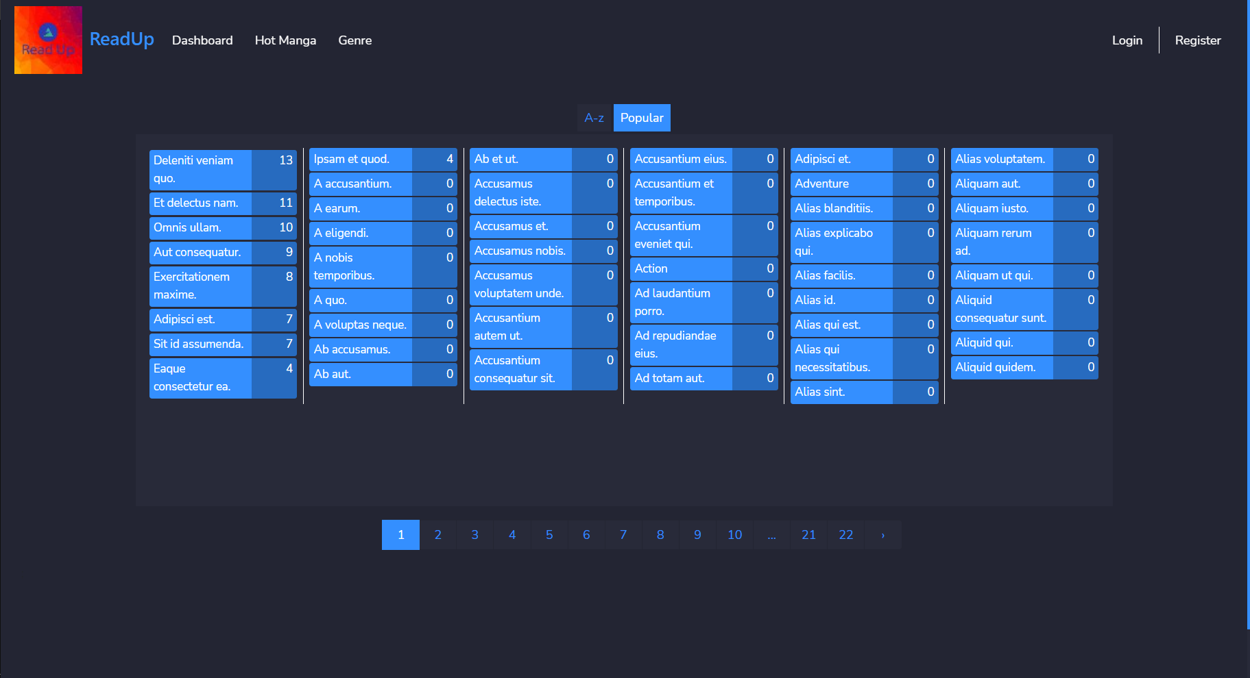

Display Manga by Genre

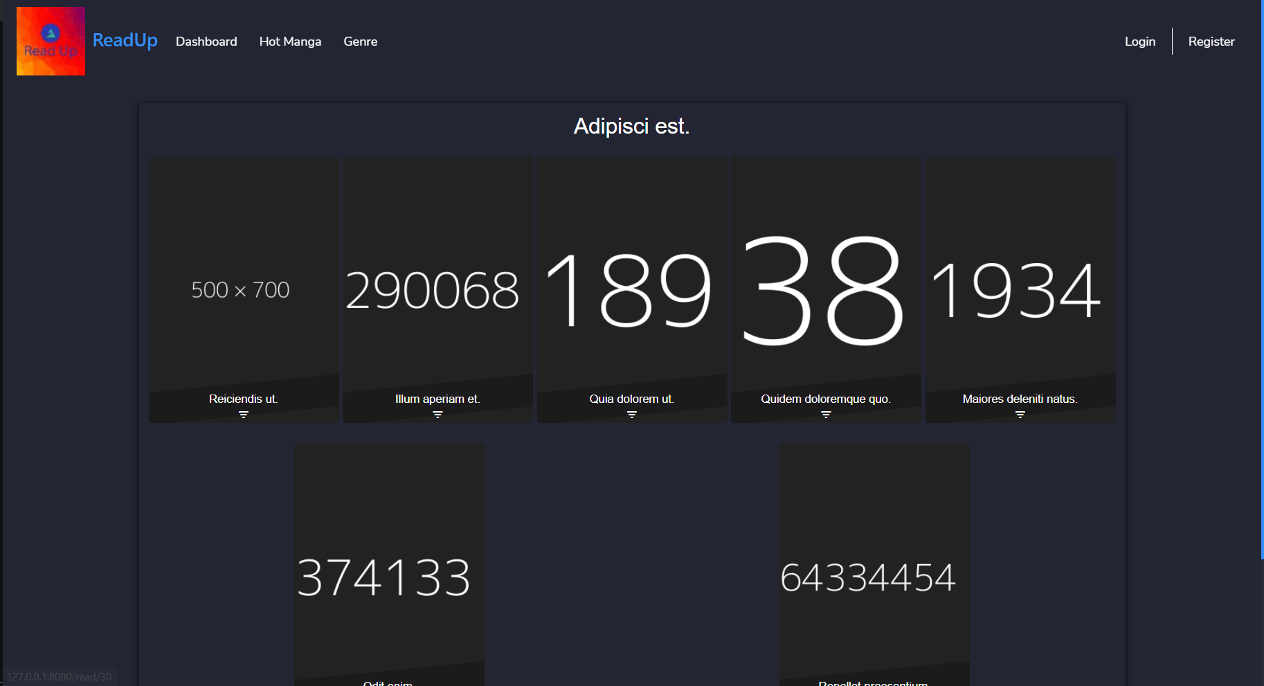

Display One Manga

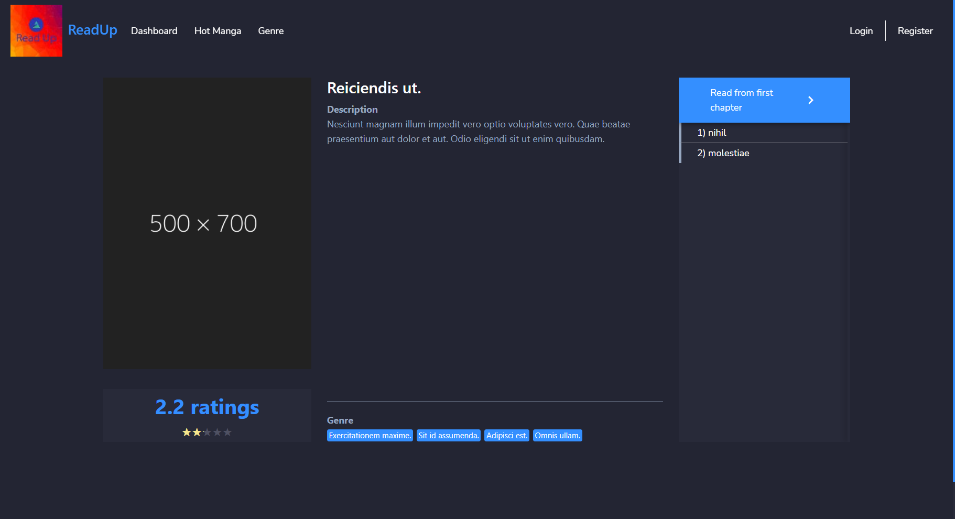

Read Manga

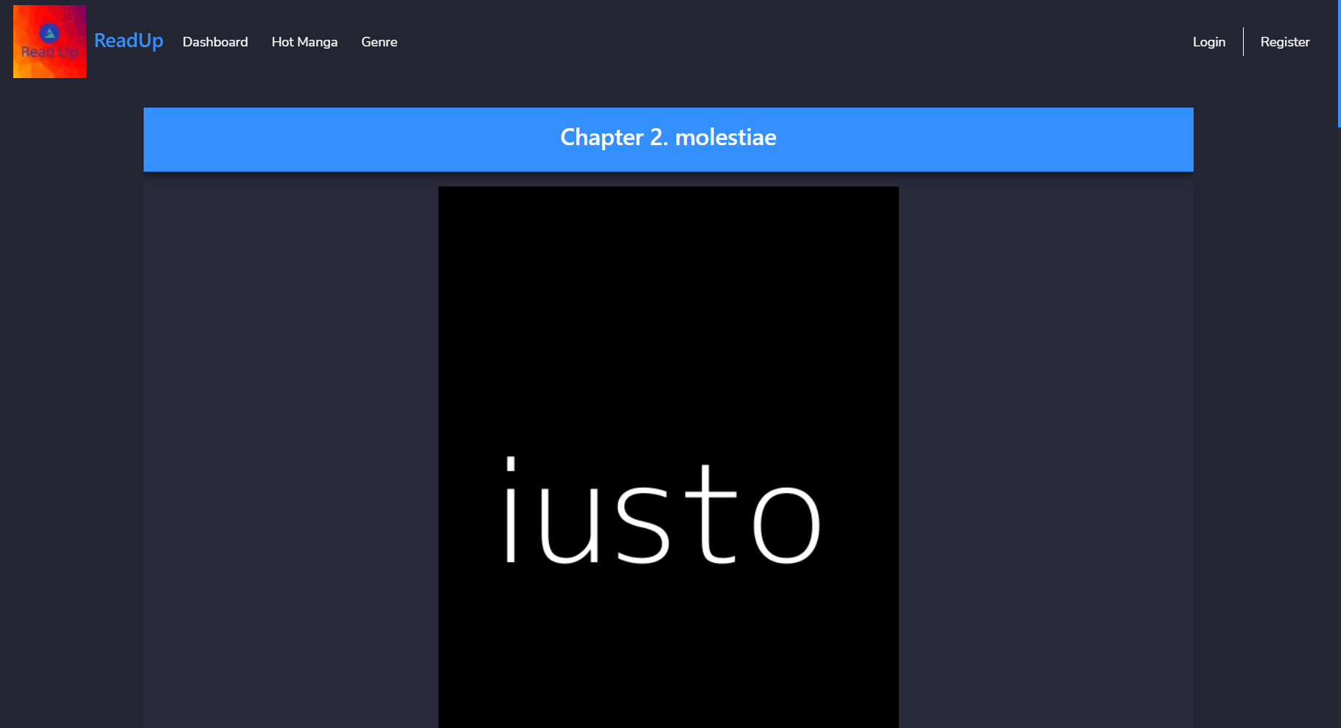

Register

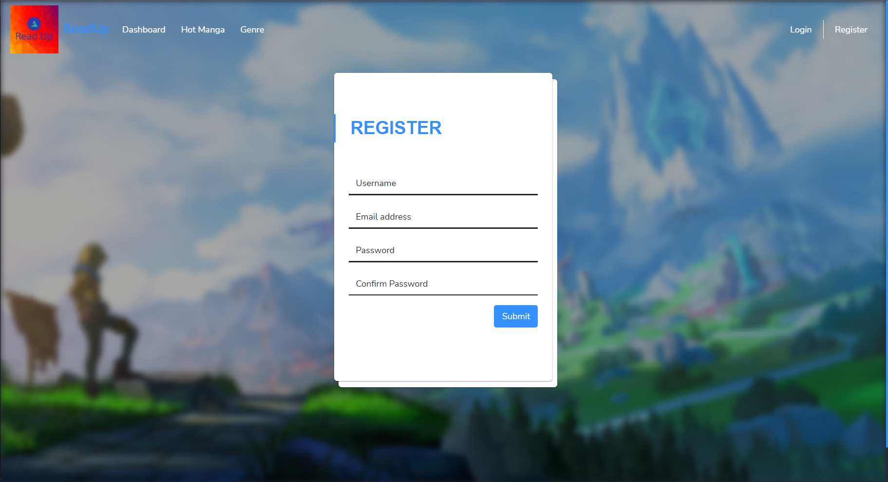

Login

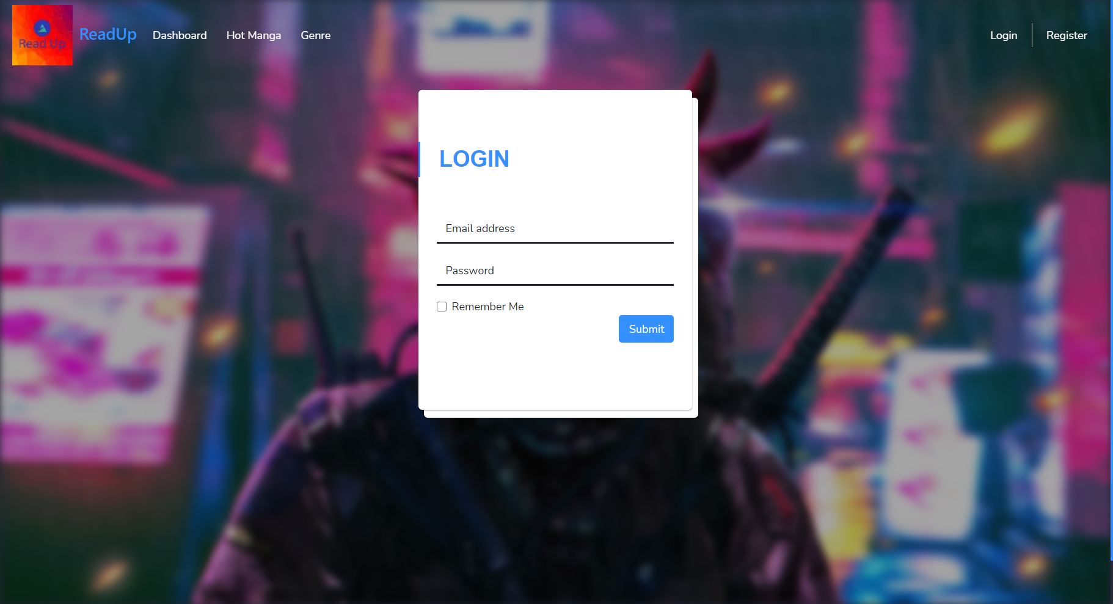

After Login Display

